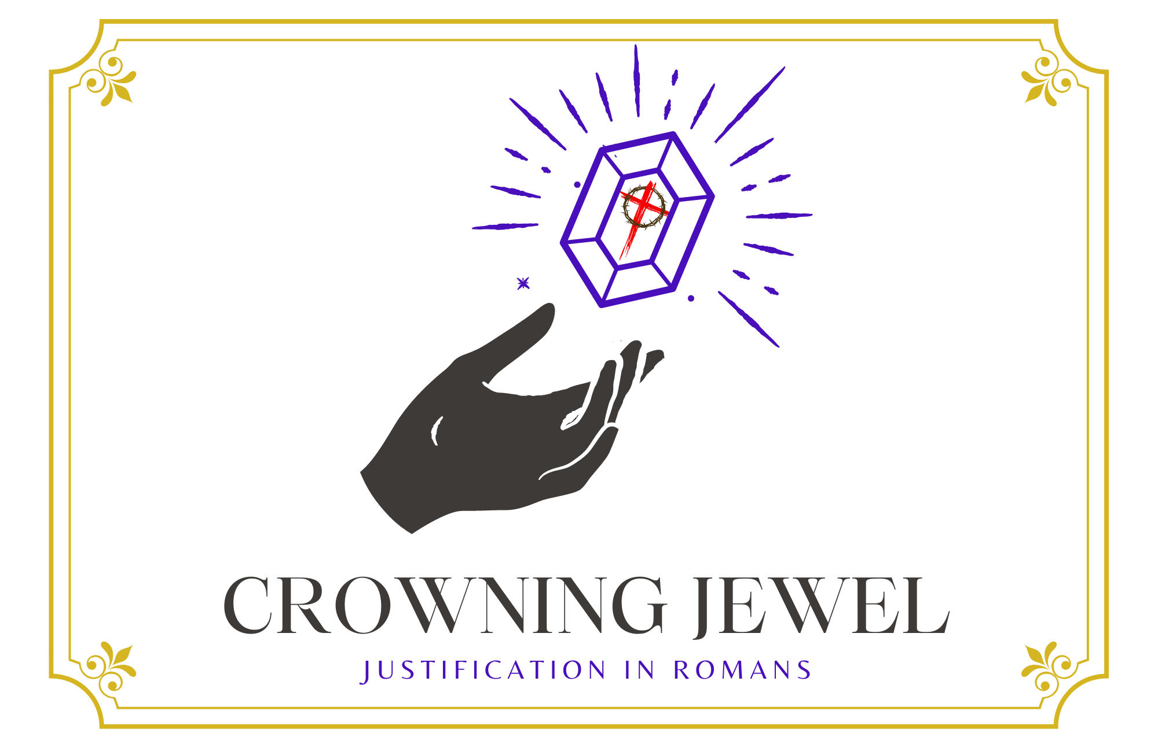

2nd Sunday of Easter

CHRIST LUTHERAN CHURCH | Lodi, California
April 7, 2024

WELCOME TO WORSHIP
Welcome to Christ Lutheran Church. We pray that your soul will be strengthened by the good news about God’s grace, love, and forgiveness given to us. If you would like to learn more about our church, please speak with our pastor or one of our members after the service.
- Bathrooms are located in the fellowship hall. A changing table is located in the women’s bathroom.
WORSHIP THEME
“These are written that you may believe.” The Easter message is handed down to us through the generations so that we might know and believe that Jesus is the Son of God and our Savior. Through faith in Christ, God grants eternal life: a life of health and gracious provision.
The Common Service
The high and holy worship of God is faith in Jesus Christ. Such faith is created and sustained by God’s service to us (the German, “Gottesdienst,” “The Divine Service”). In the Divine Service, the Lord comes to us in His Word and Sacrament to bless and enliven us with His gifts. The Service is not something we do for God, but His service to us received in faith. The liturgy is God’s work. He gives, we receive.
HYMN This Joyful Eastertide | CW 160
INVOCATION
M: In the name of the Father, and of the Son ✙ and of the Holy Spirit
C: Amen.
CONFESSION
From God’s Word we know that wherever God puts His name, there He is to bless. In the Old Testament the temple was the place where God graciously caused His name to be present (1 Kings 8:27-30).
God has put His name —Father, Son, and Holy Spirit—on us in Holy Baptism. The Divine Service begins with the Invocation, the words spoken over us at our baptisms. Every Divine Service is for the hallowing of the Lord’s name, which the Small Catechism reminds us is done “when the Word of God is taught in its truth and purity, and we, as the children of God, also lead holy lives according to it” (Matthew 28:18-20).
M: Beloved in the Lord: let us draw near with a true heart and confess our sins to God our Father, asking him in the name of our Lord Jesus Christ to grant us forgiveness.
C: Holy and merciful Father, I confess that I am by nature sinful, and that I have disobeyed you in my thoughts, words, and actions. I have done what is evil and failed to do what is good. For this I deserve your punishment both now and in eternity. But I am truly sorry for my sins, and trusting in my Savior Jesus Christ, I pray: Lord, have mercy on me, a sinner.
Lord, have mercy on us. Christ, have mercy on us. Lord, have mercy on us.

absolution
M: God, our heavenly Father, has been merciful to us and has given his only Son to be the atoning sacrifice for our sins. Therefore, as a called servant of Christ and by his authority, I forgive you all your sins in the name of the Father and of the Son ✙ and of the Holy Spirit.
C: Amen
M: In the peace of forgiveness, let us praise the Lord.
C: Glory be to God on high,
and on earth peace, good will toward men.
We praise you, we bless you, we worship you,
We glorify you, we give thanks to you, for your great glory.
O Lord God, heavenly King, God the Father almighty.
O Lord, the only begotten Son, Jesus Christ;
O Lord God, Lamb of God, Son of the Father,
You take away the sin of the world; have mercy on us.
You take away the sin of the world; receive our prayer.
You sit at the right hand of God the Father; have mercy on us.
For you only are holy; you only are the Lord.
You only, O Christ, with the Holy Spirit,
Are most high in the glory of God the Father. Amen.
PRAYER OF THE DAY
M: The Lord be with you.
C: And also with you.
M: Let us pray.
O risen Lord, you came to your disciples and took away their fears with your word of peace. Come to us also by your Word and sacrament, and banish our fears with the comforting assurance of your abiding presence; for you live and reign with the Father and the Holy Spirit, one God, now and forever.
C: Amen
FIRST LESSON Acts 3:1–20
Faith in Jesus brought a miraculous healing for the beggar in Jerusalem.
3 One day Peter and John were going up to the temple at the time of prayer—at three in the afternoon. ² Now a man who was lame from birth was being carried to the temple gate called Beautiful, where he was put every day to beg from those going into the temple courts. ³ When he saw Peter and John about to enter, he asked them for money. ⁴ Peter looked straight at him, as did John. Then Peter said, “Look at us!” ⁵ So the man gave them his attention, expecting to get something from them.
⁶ Then Peter said, “Silver or gold I do not have, but what I do have I give you. In the name of Jesus Christ of Nazareth, walk.” ⁷ Taking him by the right hand, he helped him up, and instantly the man’s feet and ankles became strong. ⁸ He jumped to his feet and began to walk. Then he went with them into the temple courts, walking and jumping, and praising God. ⁹ When all the people saw him walking and praising God, ¹⁰ they recognized him as the same man who used to sit begging at the temple gate called Beautiful, and they were filled with wonder and amazement at what had happened to him.
¹¹ While the man held on to Peter and John, all the people were astonished and came running to them in the place called Solomon’s Colonnade. ¹² When Peter saw this, he said to them: “Fellow Israelites, why does this surprise you? Why do you stare at us as if by our own power or godliness we had made this man walk? ¹³ The God of Abraham, Isaac and Jacob, the God of our fathers, has glorified his servant Jesus. You handed him over to be killed, and you disowned him before Pilate, though he had decided to let him go. ¹⁴ You disowned the Holy and Righteous One and asked that a murderer be released to you. ¹⁵ You killed the author of life, but God raised him from the dead. We are witnesses of this. ¹⁶ By faith in the name of Jesus, this man whom you see and know was made strong. It is Jesus’ name and the faith that comes through him that has completely healed him, as you can all see.
¹⁷ “Now, fellow Israelites, I know that you acted in ignorance, as did your leaders. ¹⁸ But this is how God fulfilled what he had foretold through all the prophets, saying that his Messiah would suffer. ¹⁹ Repent, then, and turn to God, so that your sins may be wiped out, that times of refreshing may come from the Lord, ²⁰ and that he may send the Messiah, who has been appointed for you—even Jesus.
PSALM Psalm 16, page 68
SECOND LESSON 1 John 1:1–4
Jesus is our life, proclaimed to us by the Apostles who saw and touched him with their own eyes and hands.
1 That which was from the beginning, which we have heard, which we have seen with our eyes, which we have looked at and our hands have touched—this we proclaim concerning the Word of life. ² The life appeared; we have seen it and testify to it, and we proclaim to you the eternal life, which was with the Father and has appeared to us. ³ We proclaim to you what we have seen and heard, so that you also may have fellowship with us. And our fellowship is with the Father and with his Son, Jesus Christ. ⁴ We write this to make our joy complete.
VERSE OF THE DAY John 20:29
M: Alleluia, alleluia. Christ is risen!
C: He is risen indeed! Alleluia!
M: Blessed are those who have not seen and yet have believed.
C: Alleluia!
THE GOSPEL John 20:19–31
The resurrected Jesus appears to his disciples and removes their doubts.
¹⁹ On the evening of that first day of the week, when the disciples were together, with the doors locked for fear of the Jewish leaders, Jesus came and stood among them and said, “Peace be with you!” ²⁰ After he said this, he showed them his hands and side. The disciples were overjoyed when they saw the Lord.
²¹ Again Jesus said, “Peace be with you! As the Father has sent me, I am sending you.” ²² And with that he breathed on them and said, “Receive the Holy Spirit. ²³ If you forgive anyone’s sins, their sins are forgiven; if you do not forgive them, they are not forgiven.”
²⁴ Now Thomas (also known as Didymus), one of the Twelve, was not with the disciples when Jesus came. ²⁵ So the other disciples told him, “We have seen the Lord!”
But he said to them, “Unless I see the nail marks in his hands and put my finger where the nails were, and put my hand into his side, I will not believe.”
²⁶ A week later his disciples were in the house again, and Thomas was with them. Though the doors were locked, Jesus came and stood among them and said, “Peace be with you!” ²⁷ Then he said to Thomas, “Put your finger here; see my hands. Reach out your hand and put it into my side. Stop doubting and believe.”
²⁸ Thomas said to him, “My Lord and my God!”
²⁹ Then Jesus told him, “Because you have seen me, you have believed; blessed are those who have not seen and yet have believed.”
³⁰ Jesus performed many other signs in the presence of his disciples, which are not recorded in this book. ³¹ But these are written that you may believe that Jesus is the Messiah, the Son of God, and that by believing you may have life in his name.
M This is the Gospel of the Lord.
C: Praise be to you, O Christ!
NICENE CREED
We believe in one God, Dt. 6:4
The Nicene Creed is the great Confession of the Christian faith professed by all Christians. The Creed originated at the First Council of Nicaea (c. AD. 325)
the Father, the Almighty, 2 Cor. 6:18
maker of heaven and earth, Is. 51:13
of all that is, seen and unseen. Col. 1:16
We believe in one Lord, Jesus Christ, 1 Cor 8:6
the only Son of God, Jn. 3:16
eternally begotten of the Father, Heb. 1:2,5
God from God, Light from Light, true God from true God, Jn. 1
begotten, not made, of one being with the Father. Jn. 10:30
Through him all things were made. Jn. 1:3
For us and for our salvation, 1 Th. 5:9
he came down from heaven, Jn. 6:38
was incarnate of the Holy Spirit and the virgin Mary, Lk. 1:35
The Creed itself was crafted as a confession of Scripture in opposition to the Arian heresy, which denied that the Lord Jesus and the Holy Spirit are God.

and became fully human. Gal. 4:4
For our sake he was crucified under Pontius Pilate. Mk. 15:15
He suffered death and was buried. 1 Cor. 15:3-4a
On the third day he rose again in accordance
with the Scriptures. 1 Cor. 15:4b
He ascended into heaven Ac. 2:33-34
and is seated at the right hand of the Father. Heb. 1:13
He will come again in glory Mt. 25:31
to judge the living and the dead, 2 Tim. 4:1
and his kingdom will have no end. Lk. 1:33
We believe in the Holy Spirit, the Lord, the giver of life, Job 33:4
who proceeds from the Father and the Son, Jn. 15:26
who in unity with the Father and the Son Jn. 4:24
is worshiped and glorified,
who has spoken through the prophets. 2 Pet. 1:25
We believe in one holy Christian Mt. 16:18; Eph. 2:19-20
and apostolic Church.
We acknowledge one baptism for the forgiveness of sins. Eph. 4:5; Ac. 2:38
We look for the resurrection of the dead 1 Cor. 15:21-22
and the life of the world to come. Amen. Rev. 22

HYMN OF THE DAY O Sons and Daughters of the King| CW 165
SERMON Acts 3
OFFERTORY
C: Create in me a clean heart, O God,
And renew a right spirit within me.
Cast me not away from your presence
And take not your Holy Spirit from me.
Restore unto me the joy of your salvation,
And uphold me with your free Spirit. Amen.
OFFERING
In response to God’s love and forgiveness, we give back a portion of what he has given us. The members of Christ Lutheran Church have joined to proclaim the gospel to this community. These offerings support that work. While our guests are welcome to participate, they should not feel obligated to do so.
PRAYER OF THE CHURCH
M: Heavenly Father, Your Son is the firstborn from the dead. In Him, we have been reborn into a new and living hope. Nurture us with the pure milk of Your Word, that we may grow to maturity of faith and have everlasting life. Lord, in Your mercy,
C: Hear our prayer.

M: Grant to those ordained for Your service the gift of the Spirit, wisdom that comes down from above, and grace to faithfully fulfill their holy calling where You have placed them. Lord, in Your mercy,
C: Hear our prayer.
M: As Your people are united in the common life and love of our Savior, grant that we would share that life and love with those in need. Lord, in Your mercy,
C: Hear our prayer.
M: Build up the households of Your people, that Your holy children, begotten in Baptism, may grow in Your grace and share together in Your forgiveness and life. Lord, in Your mercy,
C: Hear our prayer.
M: You have instituted authorities to carry out Your justice. Bless all who make, administer and judge the laws of our land. Give them wisdom, integrity and honor to serve according to Your good will. Lord, in Your mercy,
C: Hear our prayer.
M: As Your Son’s wounds brought gladness and peace to the troubled disciples, give Your presence and comfort to the troubled in our midst. Comfort also those who weep with the blessed joy of Easter morning. Lord, in Your mercy,
C: Hear our prayer.
M: Father of the risen Christ, You give us the crucified and risen body and blood of our Lord in this Holy Supper. Let us taste that the Lord is good and continually grow up unto salvation. Lord, in Your mercy,
C: Hear our prayer.
M: Lord God, heavenly Father, we thank You for Your indescribable grace,. Grant us Your Holy Spirit, that we may heartily believe Your Word; establish our faith day by day; sustain us until at last we obtain eternal salvation; through the same Jesus Christ, Your Son, our Lord, who lives and reigns with You and the Holy Spirit, one God, now and forever.
C: Amen.

LORD’S PRAYER Matthew 6:9-13; Luke 11:2-4
C: Our Father, who art in heaven,
hallowed be thy name,
thy kingdom come,
thy will be done on earth as it is in heaven.
Give us this day our daily bread;
and forgive us our trespasses,
as we forgive those
who trespass against us;
and lead us not into temptation,
but deliver us from evil.
For thine is the kingdom
and the power and the glory
forever and ever. Amen.

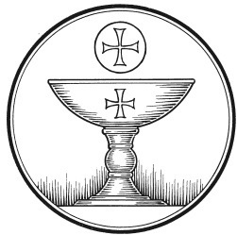
The Service of the Sacrament
This greeting marks a new service, so to speak. These ancient introductory words & phrases help to highlight, celebrate and bring attention to the Sacrament.
M: The Lord be with you.
C: And also with you.
M: Lift up your hearts.
C: We lift them up to the Lord.
M: Let us give thanks to the Lord our God.
C: It is good and right so to do.
M: It is truly good and right that we should at all times and in all places give you thanks, O Lord, holy Father, almighty and everlasting God, through Jesus Christ, our Lord, who by his willing sacrifice on the cross took away the sins of the world and by his glorious resurrection restored everlasting life. Therefore with all the saints on earth and hosts of heaven, we praise your holy name and join their glorious song:

HOLY, HOLY, HOLY – Sanctus
C: Holy, holy, holy Lord God of heavenly hosts:
heav’n and earth are full of your glory.
Hosanna, hosanna, hosanna in the highest!
Blessed is he, blessed is he, blessed is he who comes in the name of the Lord.
Hosanna, hosanna, hosanna in the highest.
WORDS OF INSTITUTION Matthew 26, Mark 14, Luke 22
M: Our Lord Jesus Christ, on the night he was betrayed, took bread; and when he had given thanks, he broke it and gave it to his disciples, saying: “Take and eat. This is my ✙ body, which is given for you. Do this in remembrance of me.”
The Words of institution both proclaim the words of Jesus to the congregation and sets apart the bread and wine for the Lord’s Supper.
Then he took the cup, gave thanks, and gave it to them, saying, “Drink from it all of you; this is my ✙ blood of the new covenant, which is poured out for you for the forgiveness of sins. Do this, whenever you drink it, in remembrance of me.”

PEACE OF THE LORD – Pax Domini John 20:19
M: The peace of the Lord be with you always.
C: Amen

O CHRIST, LAMB OF GOD – Agnus Dei John 1:29
C: O Christ, Lamb of God,
you take away the sin of the world;
have mercy on us.
O Christ, Lamb of God,
you take away the sin of the world;
have mercy on us.
O Christ, Lamb of God,
you take away the sin of the world;
Grant us your peace. Amen.
DISTRIBUTION
Those who will be receiving Holy Communion today may wish to read Personal Preparation for Holy Communion, found on page 156 in the front section of the hymnal. This page helps us put into practice what the Bible encourages: “Everyone ought to examine themselves before they eat of the bread and drink from the cup.” (1 Corinthians 11:28)
Christ Lutheran Church confesses and practices the Biblical teaching of a Closed Communion. We ask that only members of the Wisconsin Synod [WELS] or the Evangelical Lutheran Synod [ELS] join us at the Lord’s Table. If you have questions concerning our communion practice, or would like to inquire about how you, too, can commune with us, please speak with the Pastor following the service.
THE SONG OF SIMEON
C: Lord, now you let your servant, depart in peace
According to your word.
For my eyes have seen your salvation,
Which you have prepared before the face of all people,
A light to lighten the Gentiles
And the glory of your people Israel.
M: We give thanks, almighty God, that you have refreshed us with this holy supper. We pray that through it you will strengthen our faith in you and increase our love for one another. We ask this in the name of Jesus Christ, our Lord, who lives and reigns with you and the Holy Spirit, one God, now and forever.
C: Amen.
THE BLESSING
M: The Lord bless you and keep you.
The Lord make his face shine on you and be gracious to you.
The Lord look on you with favor and ✙ give you peace.
C: Amen.
CLOSING HYMN Crown Him with Many Crowns| CW 341

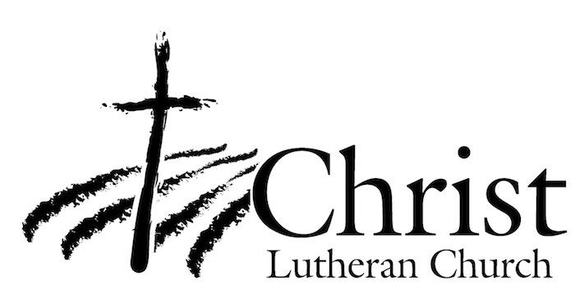
13009 N. Elderberry Ct.
Lodi, CA 95242
www.christlodi.org
209-368-6250
Pastor Timothy Leistekow
WELCOME TO CHRIST EV. LUTHERAN CHURCH!
We preach a message of forgiveness, hope and peace
through the death and resurrection of Jesus Christ.
Families and individuals of all ages will find opportunities
both to grow and to serve.
Our mission statement:
Look what Christ is doing!
He binds us together in fellowship
He gathers us in for worship
He builds us up for service
He sends us out with the gospel

“Now you are the body of Christ,
and each one of you is a part of it.”
(1 Corinthians 12:27)
COPYRIGHT INFORMATION
Content requiring a copyright license is reproduced under OneLicense.net #A-718312. All rights reserved. The Common Service: Texts revised from The Lutheran Hymnal, 1941. Music revised by James Engel. Scripture Quotations: From the Holy Bible, New International Version (NIV 1984), © 1973, 1978, 1984 by Biblica, Inc.

